**JOB DESCRIPTION**

**Post Title: Housekeeping Assistant**

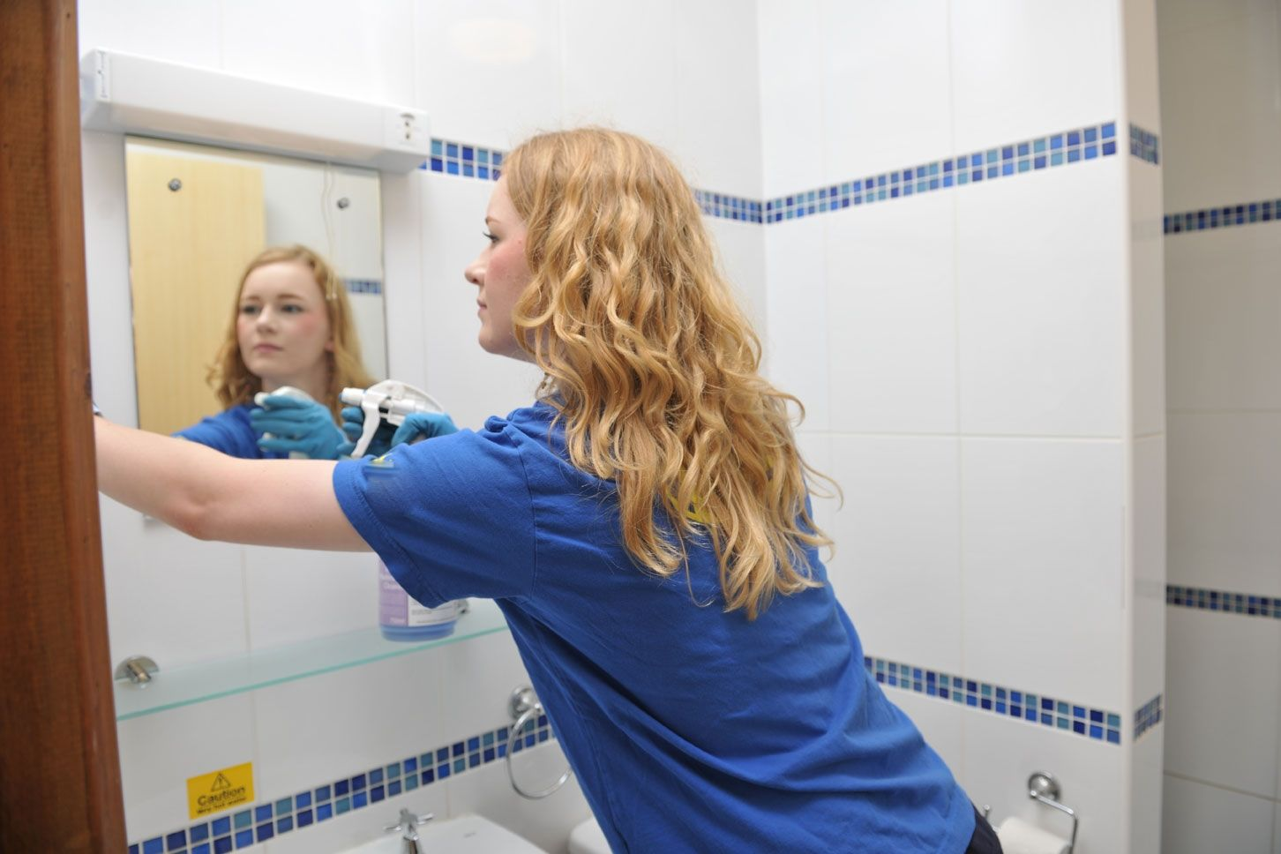

**The Association**

Rockdale Housing Association Limited was founded in 1948. It is a charity and a Registered Society. It is registered with the Homes & Communities Agency and the Care Quality Commission, and is a member of the National Housing Federation. Rockdale’s mission is to provide innovative and flexible housing and other help for older people which they can afford, and which will enable them to maintain or improve their quality of life.

**Properties in Management**

* Rockdale House
* 123 sheltered apartments for rent at Rockdale Road, Sevenoaks
* 28 sheltered leasehold apartments in Akehurst Lane, Sevenoaks
* 29 purpose built sheltered leasehold apartments at Rockdale Road, Sevenoaks

The sheltered apartments provide self-contained accommodation in studio and one bedroom apartments. Communal facilities include laundries and a large common room, where social events are regularly held. Rockdale places great emphasis on the importance of a professionally managed support service. Unlike many sheltered schemes, the support co-ordinators at Rockdale are available to residents 24 hours a day.

**Rockdale House**

Rockdale House is a registered residential care home which aims to provide a sympathetic, comfortable environment in which older people may have their personal care needs met while retaining maximum independence and continuing links with the community. We respect the residents’ rights, as citizens, to freedom of choice, privacy, confidentiality, and control over their daily lives. We operate in a new purpose-built care home with 48 residents and a well-motivated staff team under the management of a qualified care home manager.

**Job Summary**

As a member of the Housekeeping team, to keep all areas in the Rockdale House clean and tidy, and help with laundry, kitchen and dining room duties, and occasionally undertake cooking for residents.

**Accountable to:** Housekeeping Team Leader

**Key Responsibilities**

To be committed to the principle that Rockdale House is the residents’ home and that a resident’s room is his/her private domain, and to respect and promote the residents’ privacy, dignity, independence, freedom of movement and freedom of choice.

To read, understand and implement the Association’s Fire and Health and Safety policies.

On a rota basis with other members of the Housekeeping team, to dust polish, sweep, vacuum and mop all areas of the House, as listed on the housekeeping schedule supplied and revised from time to time by the Home Manager.

To work in the kitchen, prepare vegetables, wash up, clean kitchen areas and help with cooking, as required.

To work in the dining room, help to serve meals to residents, lay-up and clear tables, clean dining rooms and small kitchens, restock cupboards and wash up as required.

To launder house linen and residents’ personal clothing and make and change beds.

To be prepared to undertake other duties required from time to time by the Home Manager or Senior on duty.

**Hours of work**

Full time, Permanent, 38 hours per week over 5 shifts either early 8:00am-4:00pm or 10:00am-2:00pm or late 2:00pm-8:00pm or 4:00pm-8:00pm including weekend working.

**Salary**

£9.09 per hour basic (£11.36 enhanced)

**Post grade**

8

**Benefits**

We offer a pension and health cash-back scheme, 6 weeks annual leave increasing to 7 weeks after 5 years’ service, company sick pay payable after 6 months, a referral bonus scheme and full training and support with your professional development. Rockdale is a member of the Pensions Trust; Social Housing Pension Scheme and the post holder will be eligible to join.

**Offer**

The successful applicant will be offered the role subject to a satisfactory enhanced DBS check, and the taking up and verification of references. We also reserve the right to contact any previous employers for a reference request on your behalf.

**Application**

If you wish to be considered for this role, please submit your CV to Georgina Bozzini, HR Administrator, Rockdale Lodge, Rockdale Road, Sevenoaks, Kent, TN13 1JT georgina.bozzini@rockdale.org.uk or telephone 01732 458762 for an application pack.

**Competency Framework**

The competence framework sets out skills, knowledge and behaviours in four main competence areas, providing a means to assess performance of the above duties and responsibilities.

|  |  |  |
| --- | --- | --- |
| Competence | Description | Behaviours |
| Communicating effectively, internally and externally | Engaging in written and oral communication that is clear, transparent, and responsive to the needs, experience and understanding of diverse audiences. | Communicate using appropriate styles, methods and timing to maximise understanding, impact and inclusiveness.  Actively seek information from others to understand their needs and encourage them to access relevant information that will help them use services more effectively. |
| Working as a team | Working effectively with colleagues and using the diversity of the team to create a working environment which helps to achieve optimum performance and success. | Proactively contribute to the work of the whole team.  Actively seek input from a diverse range of people.  Be open to taking on different roles |
| Developing skills and knowledge | Keeping up to date with new processes and information in our individual role, seeking opportunities to develop, and taking responsibility for own individual personal development | Identify own skills and knowledge gaps to inform own development and discuss these with line manager  Recognise and take time to achieve own learning and development objectives. |
| Delivering effective performance | Delivering timely performance with energy, taking responsibility and accountability for quality outcomes, and dealing with challenges in a responsive and constructive way | Focus on providing the right solution and keep relevant parties up to date on progress.  Take responsibility for the quality of own work and keep line manager informed of how work is progressing.  Take ownership of problems, remaining positive and focused on achieving outcomes despite setbacks. |