
Guidelines
Rented and Leasehold apartments in central Sevenoaks, Kent

Rockdale Housing Association Limited is registered with the Regulator of Social Housing No. LH0869 and is a Registered Society as a charity No. 13507R

Rockdale Housing Association was established over 75 years ago to provide housing and support for older people in Sevenoaks. Rockdale's mission is to provide innovative and flexible housing and other affordable help for older people, and which will help to maintain or improve their quality of life.

At Rockdale we provide accommodation which has been designed to meet the needs of older people together with support from a team of support workers who will work with you to maintain your independence for as long as possible.

Living at Rockdale

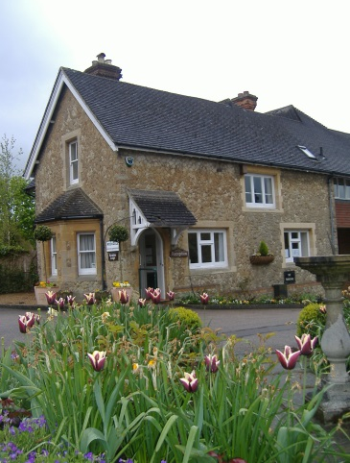
Our main site in Rockdale Road in the centre of Sevenoaks has developed over the past 60 years and we are now able to offer 123 studio and one bedroom apartments to rent and 29 one and two bedroom leasehold apartments.

This is also the location of Rockdale House, our registered care home, which offers excellent residential care in a purpose-built building with 48 en-suite bedrooms, 2 respite rooms and spacious communal rooms.

Our other site is in Akehurst Lane which adjoins Knole Park and is close to shopping and other facilities in the High Street. We have 26 one- and two-bedroom leasehold apartments to buy and 2 two-bedroom apartments to rent.

Most facilities and services managed by Rockdale are available to all residents regardless of their tenure or the location of their apartment.

Further details of our accommodation, together with useful information about Rockdale, can be found on our website www.rockdale.org.uk

What we can offer you

- Peace of mind with a team of experienced support staff available to help in an emergency at any time of the day or night.

- A telecare alarm system so that you can call for help at any time.

- Your own front door so that you can continue to welcome family and friends into your apartment whilst making new friends here.

- A full and varied programme of social activities, clubs and events which normally take place in the communal lounges.

- Proximity to Sevenoaks High Street with a good range of shops, banks, health and leisure facilities.

- Features such as raised level electrical sockets, handrails in many communal areas and spyholes for added security.

- Our well maintained gardens which take away the worry about the upkeep of your own garden.

- A good quality maintenance service from in-house staff which takes away the worry of finding reputable tradesmen.

- A reliable Home Help service (chargeable) for tasks such as cleaning, shopping, washing and ironing.

- A well-priced optional lunch service “The Pantry” which operates in Beatrice Wilson five days a week.

- Two laundry rooms, a drying room and a computer room.

- Two guest rooms to hire so that you can keep in touch with friends and family.

Our Rented Apartments in Rockdale Road
The rented apartments are all situated in Rockdale Road and arranged in separate developments. The apartments are either studios or have a separate bedroom, but all have a kitchen and bathroom. Each month rent, service and support charges are paid to Rockdale. The service charge includes the upkeep and caretaking of common areas such as the common rooms, gardens and guest rooms and the light and heat of common areas. The maintenance of lifts and laundry room equipment and external window cleaning are also included.
The rights and responsibilities of tenants and Rockdale are laid down in a Tenancy Agreement which, once signed, is binding on the tenant or tenants and Rockdale.
Beatrice Wilson
40 studio and 10 one bedroom apartments on three floors served by two lift and stairs. The common room, one laundry room, scooter storage and the computer room are situated in this block

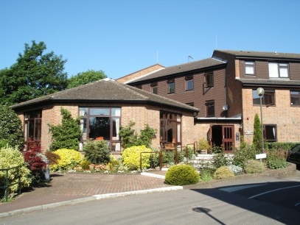
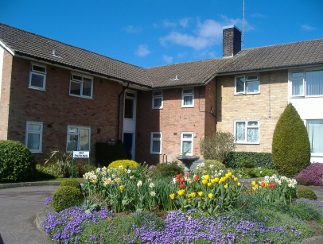
The Pleasaunce
20 one bedroom apartments with bedroom, sitting room, kitchen and bathroom with all first floor apartments accessible by stairs only

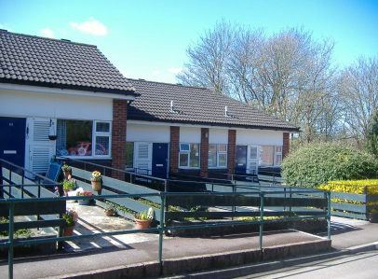
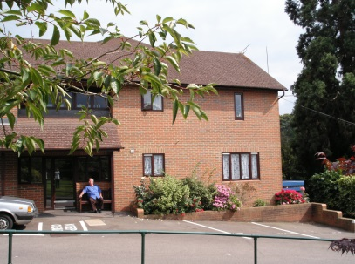
Rockdale Gardens
38 studio and 10 one bedroom apartments, first floor accessible by stairs only. A laundry room is located in this area for use by all residents

Stable Court
6 one bedroom apartments including one apartment suitable for a disabled person. First floor apartments are accessible by stairs or lift.

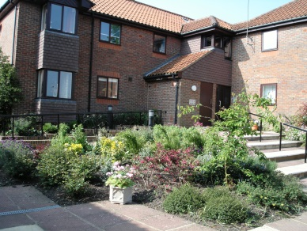
Webbs Meadow, Akehurst Lane
2 two bedroom apartments, one first floor accessible by stairs and one ground floor, with independent access.

Our Leasehold Apartments in Akehurst Lane and Rockdale Road

Webbs Meadow, Akehurst Lane
14 two bedroom and 2 one bedroom apartments in four blocks with first floor accessible by stairs or stair lift in three blocks

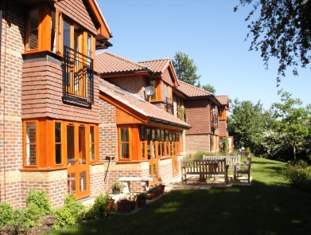
Constant Meadow, Akehurst Lane
10 two bedroom apartments first floor accessible by lift and stairs. There is a common room and drying room available for all residents in Akehurst Lane

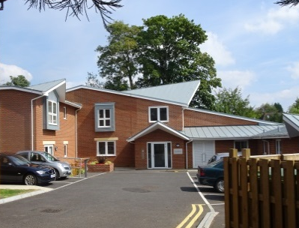
Summerbank, Rockdale Road
9 two bedroom and 1 one bedroom apartments, all accessible by stairs and lift.

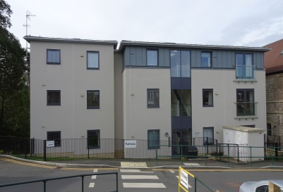
Laurie House 1-11, Rockdale Road
8 two bedroom and three one bedroom apartments, all apartments accessible by stairs and lift

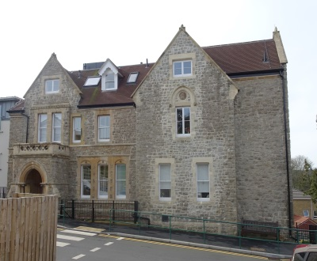
Laurie House 12 -19, Rockdale Road
1 two bedroom and 7 one bedroom apartments, all apartments accessible by stairs and lift

Service and support charges are payable monthly by all Leaseholders to Rockdale and these are detailed in the lease. Each year a breakdown of the service charge is provided to all leaseholders at Rockdale.

The rights and responsibilities of Leaseholders and Rockdale are contained in the Lease, a summary of which will be sent to you.
https://www.google.co.uk/url?sa=i&rct=j&q=&esrc=s&source=images&cd=&cad=rja&uact=8&ved=2ahUKEwjYiYePq5ncAhUDaxQKHaJAAm4QjRx6BAgBEAU&url=http://www.housingcare.org/service/ser-info-9006-visiting-befrie.aspx&psig=AOvVaw0Gj9ZrAjlv0Fncobs30B83&ust=1531477126668415

YOUR SUPPORT https://www.google.co.uk/url?sa=i&rct=j&q=&esrc=s&source=images&cd=&cad=rja&uact=8&ved=2ahUKEwjYiYePq5ncAhUDaxQKHaJAAm4QjRx6BAgBEAU&url=http://www.housingcare.org/service/ser-info-9006-visiting-befrie.aspx&psig=AOvVaw0Gj9ZrAjlv0Fncobs30B83&ust=1531477126668415

Your support is delivered in many different ways. We have a small team of
support workers who cover 24 hours, seven days a week between them so there
is always someone on duty during the day or on call at night to respond to an emergency.

Some of the other ways in which the support team may be able to help you include:
- Keeping in contact with you on a regular basis via the call system or a one-to-one visit
- Liaising with healthcare providers to help you to stay both physically and mentally well
- Arranging social events, new residents meetings, visiting entertainers, trips to the coast etc
- Collecting a prescription or doing some emergency shopping for a resident who is temporarily unwell
- Liaising with Social Services and external care agencies should you need any help with your personal care
- Finding contacts for leisure activities or voluntary work should you wish to pursue these in the community
- Arranging help for your cleaning, washing or light shopping either through our optional payable Home Help service or another agency
- Working with you to maximise the benefits and allowances you may be entitled to
- Giving advice on potential risks but not preventing you from taking them

There are some things which our support team are not able to do such as bathing, dressing, taking to the toilet, meal preparation, giving medication or handling your money or finances. However they are able to help you access the services both at Rockdale and in the wider community that you need to help you with these things.

WHO CAN APPLY TO ROCKDALE?

Rockdale has an Allocation Policy for our social rented properties, and anyone may apply if they are 60 years of age or over, or in the case of couples one is aged 60 or over, and in need of the support offered. Some applications, for example if someone has been subject to an anti-social behaviour order or poses a threat to the community, may be declined.
Equally, we assist with resell or our leasehold flats by maintaining a register of interest. And we rent one unit at present at private market rent.
All of our residents must have support needs that we are able to be met within a sheltered housing environment.

The Sevenoaks District Housing Register/Kent Homechoice

If you are interested in sheltered housing in the area other than at Rockdale you can contact Sevenoaks District Council, Housing Register Team on 01732 227000 or email housing.register@sevenoaks.gov.uk. They administer the Kent Homechoice lettings scheme and Rockdale occasionally advertises vacancies through this scheme if we have been unable to fill a vacancy www.kenthomechoice.org.uk

HOW AND WHEN TO APPLY FOR SOCIAL HOUSING

Choice Based Lettings
Moving can be stressful but we aim to make it as straightforward as possible and give you as much choice as possible when it comes to apartments. We use a scheme called choice based lettings which allows you to choose the apartment you would most like.

Application Scheme
If you are ready to move in the next year or so then now is the time to complete an application form for a Rockdale apartment. These are either available from our Reception or you can download a form from www.rockdale.org.uk and send it to us. It should be completed by the applicant if possible, but if this is a problem then we are happy to accept a form completed by a representative but it must be signed by the applicant.

What happens next?
When we receive your application, it is first checked to ensure that it meets our eligibility criteria for housing under our Allocation Policy and that we allocate an appropriate priority banding, as well as that we assess your support needs. A member of Lettings Team will then contact you to discuss your application and to answer any questions you may have. We are always happy for you to have a friend or representative with you at any meetings with us. Once we have followed up on any outstanding points such as medical or consultants’ reports (with your permission), we will write to you to confirm which priority band your application has fallen into.

Priority Bands for our social rented units
The priority bands are currently A, B, C & D, with applications in band A having
the greatest priority and those in band D the lowest. Applicants’ needs are assessed in five areas: housing tenure, current accommodation, medical health, social and welfare needs and your financial situation.

The band applied to an application will reflect the cumulative needs an applicant has in all of the five areas above which make up the bands.

We will confirm in writing in which priority band your application has been placed and the date it was banded. From this point we will advise you by letter of all rented apartments.

There is no limit to the number of properties you may bid for.

If your circumstances change once your application has been banded, you will need to let us know this so that we can review your application. If your band changes to a higher band, the date applied to the application will be the date the re-banding took effect. If your band changes to a lower band you will retain your original priority date.

We may also ask you to complete a new application form to ensure your banding is still appropriate once your application is two years old.

Bidding
When you receive details of an apartment which you wish to move to, you will need to ‘bid’ for it. This does not mean any money changes hands, it is just an opportunity for you to say you would like to move to this property or express an interest.

Each vacancy will give details of the address, bedroom size, council tax band, and a floor plan, together with a closing date for bids, any preferences and a potential tenancy start date, these will be advertised via our website. Postal copies can also be provided, if expressed. We aim to make as many properties available as possible to as large a number of applicants as possible but sometimes a preference may apply to a particular type of property such as a wheelchair adapted property to a wheelchair user. Single applicants and couples will be prioritised in the same way for all apartments.

If you wish to bid for an apartment you will need to either:

- Ring Rockdale on 01732 458762 or call into Reception and ensure you have given your name, address and the property you are bidding for or
- Email Rockdale on bidding@rockdale.org.uk giving us the same information as above.
- Place a bid for via our website https://www.rockdale.org.uk/auctions/

We will look at all the bids received by the closing date and invite the applicant/s in the highest band who has/have been waiting in that band for the longest period of time to view the property within one week of the closing date. We will also write to all other bidders giving the banding and priority date of the highest ranked bidder and their own priority ranking on that occasion.
Lower ranked bidders may be contacted at a later date if the highest ranked applicant is unwilling or unable to proceed.

Viewing
When we send out details of vacancies it is unlikely that they will be available for internal viewing at that time. You are always welcome to look around the site and at the outside of the property. If you make a bid and are offered the property, we will always offer you the opportunity to look at it before you commit to moving.

Rockdale aims to hold an open event every year or so at which different types of rented properties are available for internal viewing to give applicants the opportunity of seeing the types of apartments we have.

Timing your move
When you make a successful bid on a rented apartment, you will normally have a week to arrange to view the property internally and a further week to sign the Tenancy Agreement, which will include the tenancy start date. There is no need for you to move into the apartment on the tenancy start date, but rent, service and support charges will be payable from then onwards.

HOW TO EXPRESS INTEREST IN PRIVATE RENTED OR LEASEHOLD APARTMENT

We maintain a register of interest for our private rented and leasehold resell apartments. When a private rent or a leasehold unit becomes available for sale or rent, we will contact those who expressed interest to inform them about the opportunity to either rent or purchase.

We will offer a viewing and an opportunity to proceed with the rent/acquisition to all interested parties and we will assist to proceed with the transaction on a first come first serve basis.

For leasehold apartments, once the purchase is agreed between the vendor and the purchaser, we’ll put your solicitor in touch with the vendor’s solicitor and your purchase proceeds via these two parties. Further details of the procedure for buying an apartment are sent to you when you have applied.

APPEALS
Rockdale has an Appeals Procedure which you can use if you wish to appeal about any decision made about your application.

Appeals Procedure
If the applicant or his or her representative or Care Manager wishes to appeal against any decision relating to the applicant made by the Association or wishes to complain about the way in which the application was handled, he or she should write in the first instance to the Head of Property and Housing Management, Rockdale Housing Association, c/o Rockdale Lodge, Rockdale Road, Sevenoaks, Kent TN13 1JT.

The Head of Property and Housing Management will review the documentation relating to the case, and if he or she feels it necessary, meet the applicant. The Head of Property and Housing Management will then make a decision on the appeal or complaint on behalf of the Association and notify the applicant of the decision in writing.

If the applicant still feels the matter is unresolved he or she can make a final appeal to the Chief Executive, writing c/o Chief Executive at the same address (Rockdale Lodge).

All appeals or complaints and their outcomes will be given to the Quality & Assurance Committee.

Rockdale Housing Association
Rockdale Lodge
Rockdale Road
Sevenoaks
Kent TN13 1JT
T 01732 458762I
E enquiries@rockdale.org.uk (for general enquiries)
E bidding@rockdale.org.uk ( for bidding on properties)

